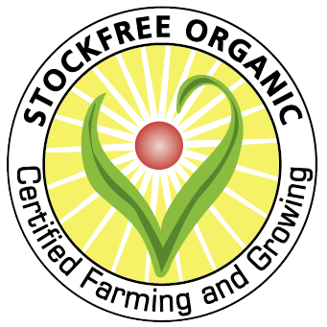
Application form to use restricted rotations – monocropping in a greenhouse or polytunnel

Licence details
Licence number
Surname
Postcode
Date of last inspection

- The Stockfree-Organic standard have restricted monocropping in protected cropping to encourage best rotational practice
- An example of a protected cropping rotation to provide a diverse crop range could include:
  - Plot 1, Red clover
  - Plot 2, Maincrop Tomato
  - Plot 3, Early crucifers and overwinter brassica salad leaves
  - Plot 4, Early lettuce and overwinter non brassica salad leaves
  - Plot 5, Early tomatoes and maincrop peppers and aubergines
  - Plot 6, Overwinter alliums, early alliums, overwinter carrots, early beetroot, maincrop celery
  - Plot 7, Legumes and overwinter salad leaves
  - Plot 8, Cucurbits

- Please indicate the dates you intend to adopt monocropping in your greenhouse or polytunnel:

- Please provide additional details justifying your need to monocrop in your greenhouse or polytunnel:

Declaration
- To the best of my knowledge the information that I have supplied on this documentation is correct
Name: |  | Date:
Signature:
I have completed this form electronically and confirm I am in agreement with the declaration above

Guidance

- Growing the same annual crop in the same soil for several years (e.g. continuous tomatoes) constitutes monocropping for the purposes of this standard
- Transplant raising or growing green manures does not constitute monocropping
- Please note that permission to use these restricted practices must be granted on each separate occasion

